**User Manual**

Group 13

Yani Liang, Yue Guan, Ding Zhang

The Pebble smartwatch TemperatureApp provides the following **functionalities**.

* User is able to check the most recent temperature. Data is detected and recorded once per second.
* User is able to check some basic statistics within the past hour, such as the average, low, and high temperature.
* User is able to convert the temperature unit between Celsius and Fahrenheit.
* User is able to put the Arduino sensor to a stand-by mode, and is able to resume the sensor.
* User is able to see the temperature history curve of the past one minute.
* User is able to calibrate the temperature based on the actual temperature.
* The Pebble smartwatch should vibrate when temperature is too high.

The application mainly contains three components: Arduino sensor and display, middleware server, and user interface Pebble smartwatch.

**Sensor and Display:**

* connect the sensor with the server’s computer
* open the temperature.ino file in Arduino
* check if the board is “Arduino Uno”
* select the corresponding Serial Port
* click “Verify” and then click “Upload” to start the Arduino
* Do some checking by opening the monitor in the software, but when running the server instead, the monitor need to be closed

**Middleware:**

* Copy and paste project.c and Makefile into a folder on your computer
* Open a terminal directing to the folder created above
* Run *make all* in the command line on the terminal to compile the c code
* Run *./output 3001* to run the server.
* Now, you are ready to setting up the watch for remotely measuring temperature

**User Interface:**

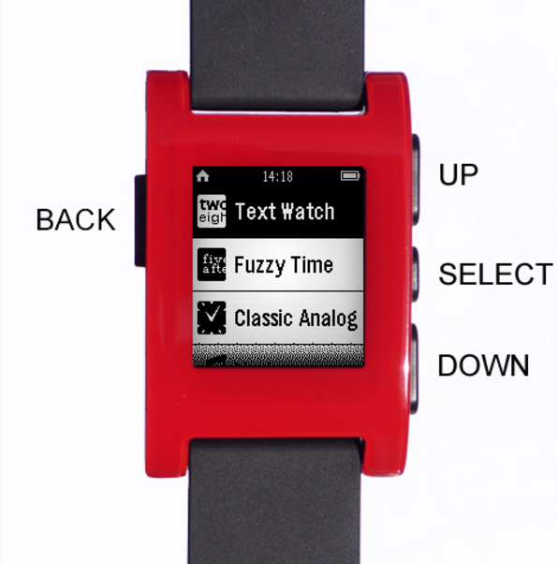

* Select button single click: show temperature information including current, average, minimum, and maximum temperature in turn.
* Select button long click: convert temperature unit between Celsius and Fahrenheit.
* Down button single click: show temperature history curve within the most recent one minute.
* Up button long click: calibrate the temperature according to the actual temperature. Increase the temperature by one degree.
* Down button long click: calibrate the temperature according to the actual temperature. Decrease the temperature by one degree.
* Up button single click: put the sensor into stand-by mode. In this situation, the watch does not report temperature information any more. Arduino sensor display does not show temperature information. However, Arduino keeps tracking the temperature records including the high, low, and average value.
* Up button double click: resume the Arduino.